

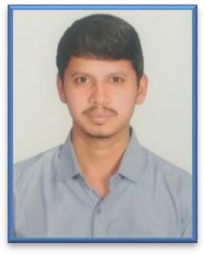



Personal Details .

|  |  |
| --- | --- |
| Name | Prathap C |
| Designation | Analyst |
| Birth Date | 10/12/1997 |
| Residence | Shivamogga, Karnataka |
| Nationality | Indian |
| Marital Status | Single |
| Gender | Male |

Profile .

|  |  |
| --- | --- |
| Designation | Analyst A4 |
| BU | Big Data |
| DOJ | 7th June, 2022 |
| Service Line | I&D DM |

Competencies .

# Cloud Platform Amazon Web Service

|  |  |
| --- | --- |
| Languages | Java, SQL |
| Database | Oracle, MY SQL |
| Operating Systems | Window |

Frame work Django

Languages .

|  |  |  |  |
| --- | --- | --- | --- |
| Languages | Speak | Read | Write |
| English | Fluent | Fluent | Fluent |
| Kannada | Fluent | Fluent | Fluent |



**Prathap c**

SKILLS SET

Domain Experience.

|  |  |
| --- | --- |
| Project | GE Data Archival Project |
| client | GE Gas power |
| Role | API Integration developer |
| Technologies used in project | VS code, PostgreSQL, postman, |
| Programming Languages used | Python, SQL, Django Rest Framework |
| Description | Working on creating API’s using python and Django Rest Framework. |

Education.

|  |  |  |
| --- | --- | --- |
| **EXAMINATION** | **YEAR** | **INSTITUTION** |
| B.E. MECHANICAL ENGINEERING | 2020 | Kalpataru Institute of Technology, Tiptur, Karnataka |
| th  12th | 2016 | Sacred Heart P.U College, Shivamoga |
| 10th | 2014 | Sri Morarji Desai Model Residential School, Anaveri, Bhadravathi |

|  |  |
| --- | --- |
| Address | Thimmappa Swamy Temple Road, Barandur, Bhadravathi(TQ), Shivamogga(DIST), Karnataka- 577245 |
| Mobile | 9845437590 |
| Corporate Email | [PRATHAP.A.C@CAPGEMINI.COM](mailto:%20%20%20%20%20%20%20PRATHAP.A.C@CAPGEMINI.COM) |